The European Clean Hydrogen Alliance
The Industrial Strategy Communication adopted on 10 March announced the creation of the European Clean Hydrogen Alliance, with the aim to bring all stakeholders and identify technology needs, investment opportunities, regulatory barriers and enablers to build a clean hydrogen ecosystem in the EU.
Clean hydrogen enables deep decarbonization of the most emitting and hard-to-abate sectors of the economy, like steel and chemicals. At the same time it opens up business opportunities for EU industry to lead the transition towards a carbon neutral future, based on EU leadership in a number of key hydrogen related technologies (such as electrolysers). Accordingly, clean hydrogen has also a lot of potential for the recovery strategy. However, full-scale industrial deployment requires systemic action along the whole value chain, from hydrogen production and transport to the industrial use as feedstock for energy-intensive industries or as fuel for transport or balancing the renewable electricity output.
The Clean Hydrogen Alliance will pool resources to bring sufficient scale and impact to industrialization efforts, creating momentum towards a sustainable industrial hydrogen ecosystem in EU. It will accelerate scaling up by bringing together all segments of the ecosystem (supply, demand and distribution) to get the scale for cost reductions and competitiveness.
The hydrogen industry and other stakeholders (e.g. regions of the Hydrogen Valleys – led by Aragon, Auvergne Rhône Alpes, Normandie and Northern Netherlands and gathering 35 European regional authorities from 13 European countries) have welcomed the alliance concept very enthusiastically. Hydrogen Europe took a lead and has worked actively towards a proposal for governance of the Alliance together with GROW (described below) while mobilising the hydrogen ecosystem towards launching of the alliance. The European Clean Hydrogen Alliance will be driven by industry but it will also include all stakeholders in the hydrogen ecosystem, i.e. industry, Member States and regions, trade unions, NGOs, research and technology organisations and civil society. It will be structured along the industrial value chain with a flexible, cross-cutting and inclusive approach ensuring close co-operation between the pillars.
The Alliance is to be launched on June 24 afternoon, the day of the adoption of the Hydrogen Strategy and the Energy System Integration Strategy. The launch meeting of the Governing Board will set the scene, agree on main deliverables and organise first workstreams. The main deliverables should include a pipeline of large-scale investment projects in the clean hydrogen ecosystem (including IPCEIs) and the roadmap addressing the main bottlenecks for the scaling up of clean hydrogen in the EU (e.g. procedures, standards, technology development, regulations).
Annex
- The proposed governance of the Hydrogen Alliance
In order to insure at the same time sufficient breadth and depth of the deliberations, recommendations and actions of the Hydrogen Alliance and to include all interested stakeholders the work is partitioned into:
- A Governing Board consisting of the VP/Commissioner (permanent chair) and representatives from each industrial pillar (12 – selected by Hydrogen Europe), regions and cities (2), civil society (3), Clean Hydrogen Partnership (FCH JU) and Member States (3). The Governing Board ensures coherence and completeness of the activities of the various workstreams around Industrial Pillars.
- Work will be organised around six Industrial Pillars. These workstreams will be organised by Hydrogen Europe, with participation open to other stakeholders (Member States, regions, civil society).
- An EU Clean Hydrogen Forum event provides room for plenary discussions with all alliance members at political as well as technical level. It includes a facility for wider exchange with the industrial community, civil society and regions and cities. (co-organised by Hydrogen Europe & Commission).
- The Commission will ensure cooperation with Member States, with a view to coordinate Important Project of Common European Interest (IPCEI) and enable action by Member States, involving various ministries as appropriate (energy, industry, transport).

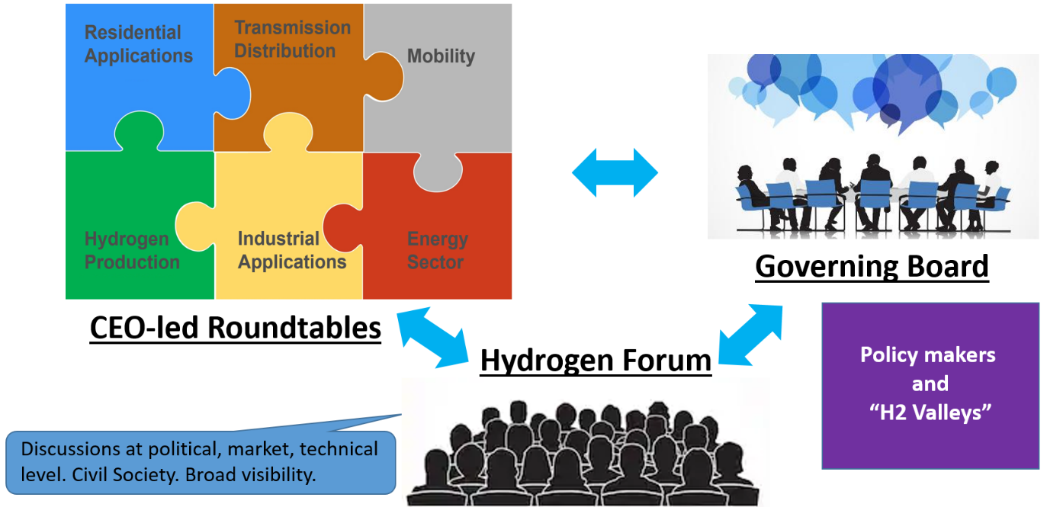

The initial members of the Governing Board are proposed by Hydrogen Europe (for industry representatives) and the Commission (for other stakeholders) with alternate/back-up members. The Governing Board members could rotate after 2 years, with the member and alternate exchanging positions.
Draft List of Clean Hydrogen Alliance Initial Governing Board Members
 |  | Name | Company/Organisation | Job Title
Commission
Member States |  | Andreas FEICHT | Council Presidency | German State Secretary BWI
 |  | Joao GALAMBA | Portugal | State Secretary for Climate and Energy
 |  | Silvana JIROTKOVA | Czech Republic | State Secretary for Industry
Regional Dimension |  | Nienke HOMAN | Region North Holland | Regional Minister for Industry
 |  | Javier LAMBAN | Region Arragon | President
 |  | Laurent WAUQUIEZ | Region Auvergne Rhone Alpes | President
Civil Society |  | Alvars STARIKOVS | Latvian Hydrogen Association | President
 |  | Tom BROOKS | European Climate Foundation | Executive Director
 |  | Luc TRIANGLE | Industry All | General Secretary
Industry |  | Jorgo CHATZIMARKAKIS | Hydrogen Europe | Secretary General
Hydrogen Production |  | Jon LOKKE | NEL (SME) | CEO
 |  | Ben VAN BEURDEN | Shell | CEO
 |  | Wolfgang ANZENGRUBER | Verbund AG | Chairman of the Board
Transmission & Distribution |  | Marco ALVERÀ | SNAM | CEO
 |  | Daniel TEICHMANN | Hydrogenious (SME) | CEO/Founder
 |  | Allard CASTELEIN | Port of Rotterdam | President & CEO
Mobility |  | Gerrit MARX | CNH Industrial | President Commercial Vehicles
 |  | Florent MENEGAUX | Michelin | CEO
 |  | Ola KÄLLENIUS | Daimler | CEO
Industry |  | Heinz Jörg FUHRMANN | Salzgitter | CEO
 |  | Charlie SHAVER | Nouryon | CEO
 |  | Volkmar DENNER | Bosch | CEO
Energy Sector |  | Han FENNEMA | Gasunie | CEO
 |  | Jean-Bernard LÉVY | EDF | Chairman and CEO
 |  | Magnus HALL | Vattenfall | President and CEO
Residential Applications |  | Martin VIESSMANN | Viessmann | Chairman
 |  | Joe KAESER | Siemens Energy | President and CEO
 |  | Andreas PICHLER | SolidPower (SME) | CEO
European Partnership |  | Bart BIEBUYCK | FCH JU | Executive Director

The Alliance can create ad-hoc working groups for specific purposes necessary for the objectives of the Alliance, and invite also non-members to present specific topics.
Inclusiveness and transparency of the Alliance is ensured by open membership for organisations with interest for the hydrogen ecosystem. All Members can participate in the EU Hydrogen Forum and are kept informed about the Alliance initiatives and progress. The relationship between stakeholders and the governance structure can be summarised as:
- Industry has seats in the Governing Board and the Industrial Pillars. The membership of the Alliance is open for all interested industries. An industrial member can participate in any number of Industrial Pillars and the Annual Forum.
- Member States, including Council Presidency, have seats in the Governing Board. Any Member State and ministry can participate in Alliance activities, and participation of several ministries per Member State is encouraged.
- Civil society has Governing Board seat and will have a facility for exchange in the Annual Forum.
- Research and innovation community can participate as members, and are represented in the Governing Board on EU level by the Clean Hydrogen Partnership (or FCH JU).
- Regions and cities have seats in the Governing Board. Exchange with broader participation from regions and cities is facilitated in the Annual Forum.
- EU institutions: The European Parliament, via relevant Committees/MEPs, will be informed by the Alliance of its activities and detailed work plan. The Commission is permanently chairing the Governing Board and participate in Industrial Pillars.
- Initial Activities of the Hydrogen Alliance
24 June Kick-off for the Alliance. Launch meeting of the Governing Board. Press event.
July 2020 Kick-off meetings of 2-3 Industrial Pillars;
Sep 2020 First Full Governing Board meeting.
Nov 2020 Second meeting of Industrial Pillars.
Dec 2020 First EU Hydrogen Alliance Forum, back to back with Governing Board meeting.
Presentation of progress in Alliance initiatives, including initial recommendations on regulatory/administrative/bureaucratic simplifications as well as policy recommendations, in particular with regards to revisions of related Regulations and Directives.
1 H 2021 Main deliverables will be:
- Making use of available toolbox for implementation of the Hydrogen Strategy
- Progress on IPCEI
- further recommendations concerning regulatory/administrative framework
- proposals for further support measures required to increase Clean Hydrogen up-take
June 2021 Second Annual Hydrogen Alliance Forum
- The proposed industrial pillars of the Hydrogen Alliance
Hydrogen is very versatile and the value chain encompasses a broad range of sectors where green hydrogen plays a role to support climate action, including activities such as:
- Generation of Clean Hydrogen - focus on renewable electricity as source.
- Transportation of Hydrogen – Includes also truck and railway tube trailers, cargo ships and pipelines, and any carrier forms (liquefied, pressurized, LOHC, NH3, etc).
- Mobility sector – focus on Fuel Cells and refuelling stations (heavy duty vehicles (HDVs), busses, trains, barges, seagoing vessels, etc.
- Industry applications – Including also steel, fertilizers, cement, needs for industrial heat, refineries and the chemical sector.
- Energy Sector – including also storage of hydrogen (short and long term) and operation in the electricity grid.
- Housing sector - Combined Heat and Power (CHP) and other household applications.

- The outcomes and deliverables
The expected outcomes are of manifold nature from awareness creation via industry ecosystem integration to massive scale-up of the sector and more hydrogen valleys in the EU. They include items such as:
- Definition and Management of a Green Hydrogen Investment and Support Plan;
- Development, link-up and coordination of IPCEI projects on Hydrogen;
- Creation and animation of an EU marketplace for new business opportunities and industrial partnerships;
- Strategical advice and studies to facilitate large scale projects;
- Co-ordination/arbitrage platform between large scale production and demand managementand develop a model case for industrial symbiosis;
- Identification and staging of then necessary hydrogen transport infrastructure networks;
- Regular updates of the outlook of the hydrogen related activities and key performance indicators;
- Creation of awareness and high level visibility in order to attract more private investments;
- Dialogue with the civil society on the challenges of this disruptive process for the energy transition;
- Contribution to the definition and adjustments of mid-term targets in the context of the European Green Deal;
- Support in identifying the main obstacles and bottlenecks (regulatory, administrative, bureaucratic, funding and other) for an industrial approach to hydrogen technologies;
- Substantial focus on renewable electricity and integrated green hydrogen factories;
- Definition and leadership of hydrogen value chain related EU Standardisation requirements;
- Ensure EU innovation leadership on Hydrogen by providing targeted work plan and pilot project input to the Clean Hydrogen JU to close the most demanding gaps and enable rapid scale-up;
- Elaboration of a well tuned and synchronized roadmap to show the path to an ambitious deployment of hydrogen technologies for the years until 2030 in form of parallel linked evolution scenarios for the various pillars of the Alliance.
More details for each of the deliverables and further additions to the list are to be elaborated during the first 6 months of the Alliance in a bottom up process.

? Hydrogen Europe is the European Hydrogen and Fuel Cell Association. It currently represents more than 160 industry companies, 78 research organizations as well as 21 National Associations. The association partners with the European Commission in the innovation programme Fuel Cells and Hydrogen Joint Undertaking (FCH JU).

